**Applications Year 12 Investigation 1 2018**

**Pre Task Activities**

1. Investigate the relationships between the

***Temperature at 9* am** and

1. the ***temperature at 3pm***
2. The ***maximum daily temperature***

|  |  |
| --- | --- |
|  |  |
|  |  |

Use your information to answer these questions

If the temperature at 9 am is 21.1º

* predict the temperature at 3 pm and the Max temperature

***3pm : 27.81*** º

***Max: 29.24*** º

* comment on the reliability of both predictions

**Reasonable reliable moderate positive linear relationship - Interpolation**

Nine and max has a higher correlation, more reliable

If the temperature at 9 am is 25 º

* predict the temperature at 3 pm and the Max temperature

***3pm : 31.74*** º

***Max: 33.42*** º

* comment on the reliability of both predictions

***Extrapolation – Therefore unreliable***

1. What is the formula to calculate the residuals of the each predication?

***Residual = actual y value – predicted y value***

Calculate the residuals for the Temperature at 9am and 3am and sketch a graph of them.

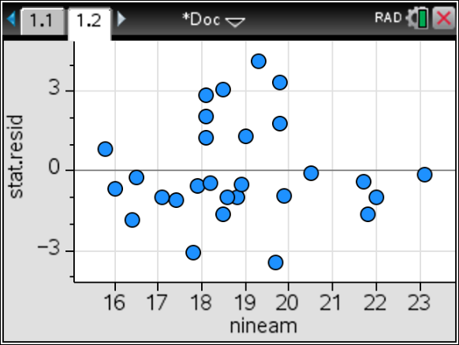

Use the residual plot to decide if the data being investigated is linear or non-linear

***A linear model is appropriate here are there is no pattern in the residuals***

1. Does a Higher temperature mean cause increased Evaporation?

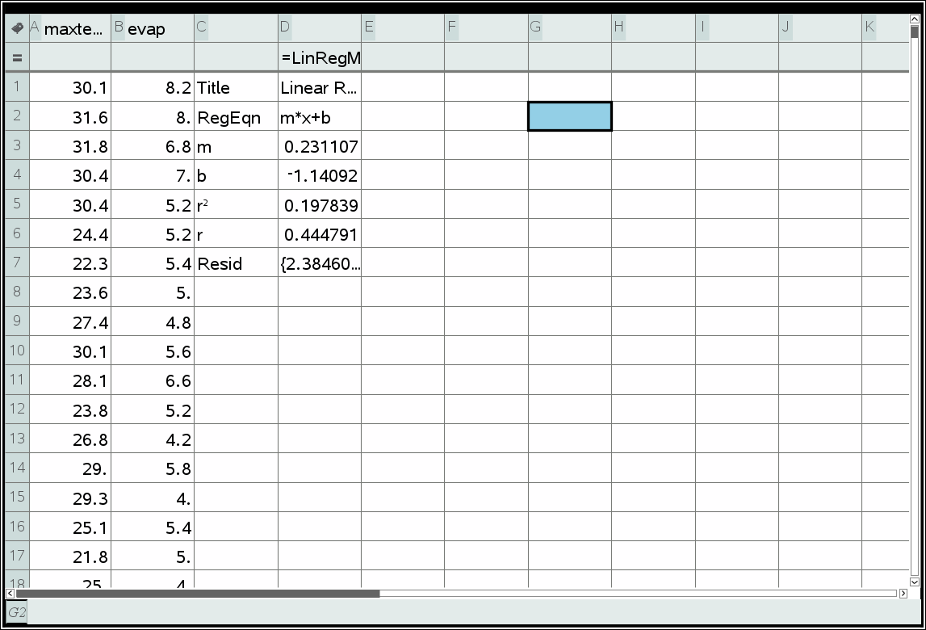

***No low correlation and even if there was correlation does not mean causation***

**In Class Validation Answers**

From the April 2017 weather data consider the Date and the Max Temperature data

1. Identify the response variable and the explanatory variable

Response ___________________________

Explanatory___________________________

|  |
| --- |
| Solution |
| Response is Max Temperature  Explanatory is Date |
| Specific Behaviours |
| ✓✓Identifies correct Variables |

1. What is the correlation coefficient and equation of the line of regression for this relationship to 2 decimal places?

|  |
| --- |
| Solution |
| r = -0.36  y= -0.11x+28.74 |
| Specific Behaviours |
| ✓ determines the correlation coefficient  ✓determines the line of regression |

1. Predict the temperature on April 31st using the equation

|  |
| --- |
| Solution |
| 25.33 |
| Specific Behaviours |
| ✓ Correctly predicts the temperature |

1. Comment on its reliability

|  |
| --- |
| Solution |
| Not reliable - extrapolation  low correlation |
| Specific Behaviours |
| ✓ Correctly states the reliabilty and states valid reason why |

**Question 2**

